Deploy a React application on EC2 through Jenkins

And Send Email Notification

**STEP 1** :

Install jenkins and nodejs on your system.

Configure Credentials under manage jenkins to add github login details and also create a credential for EC2 SSH connection

* Under Credential,click on Add credential and select username with password.
* Username should be the username of your github.
* Add the password for the github .
* Give an ID name and description .

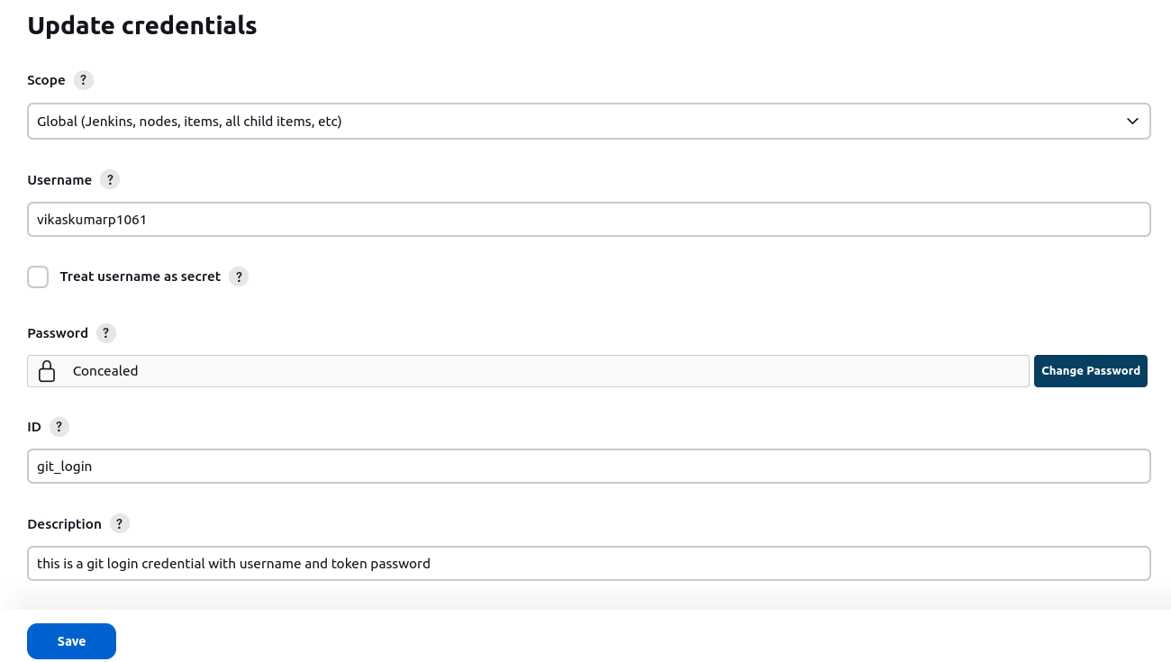

* Below image is the credential for ec2 ssh connection.
* Add the IP-Address of instance under ID (not necessary)
* Provide the username as Ubuntu
* Paste the pem file contents inside the **“Private key”** option.

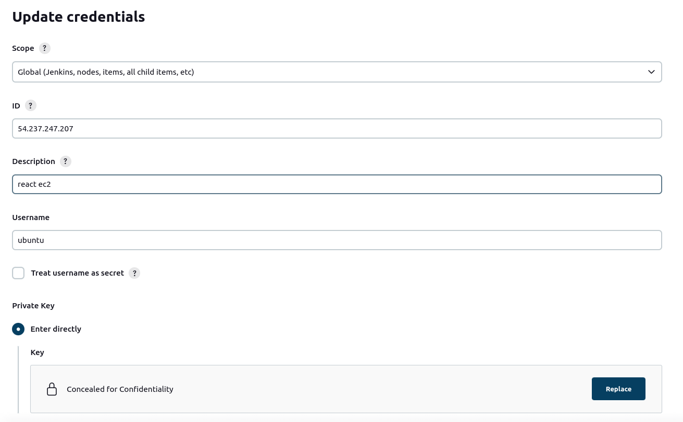

**STEP 2** :

Configure Systems under manage Jenkins

* In Dashboard, click on Manage Jenkins > System.
* Add the hostname as IP address and port number as 22 and also give the credential which was created and test connection.

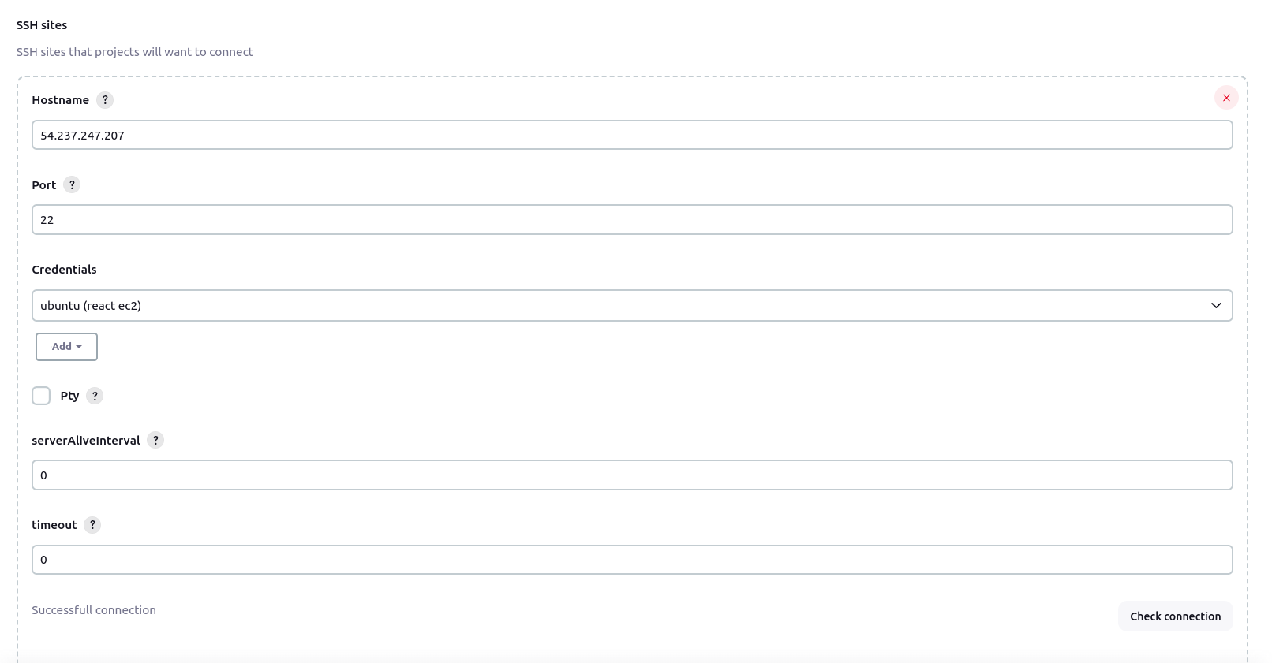

* Scroll down and add the following details under Publish over SSH.
* Hostname should be the ip-address of the instance to which we want to deploy the application.
* Username is the name of the user in the EC2.
* Remote directory is the path to which we want to store the files related to the application.
* Click on advanced to add the authentication type as password.
* Copy the contents of the pem file and add it inside the KEY box.
* Set port to 22 and test the configuration, then click on apply and save.

NOTE: In SSH server, when testing the configuration we get error because we have not changed the permission in EC2,since by default, html file permission is under root user,so this error can be neglected.

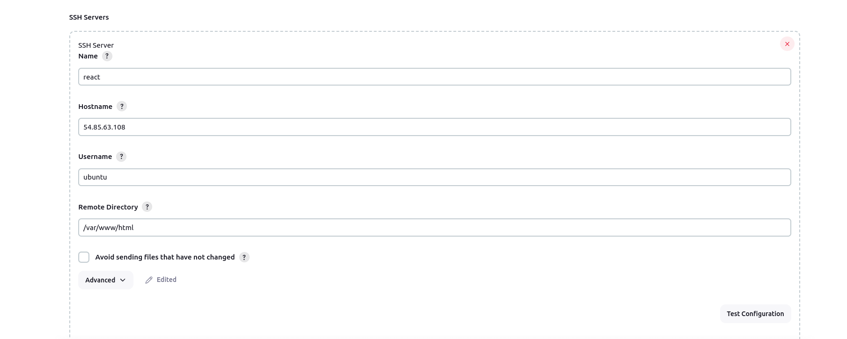

**STEP 3 :**

Create a project and build it.

* Now go back to the dashboard, select new item and give a name and select freestyle project.
* Under Source Code management, add the git project url and set the branch name which is in github for that project.

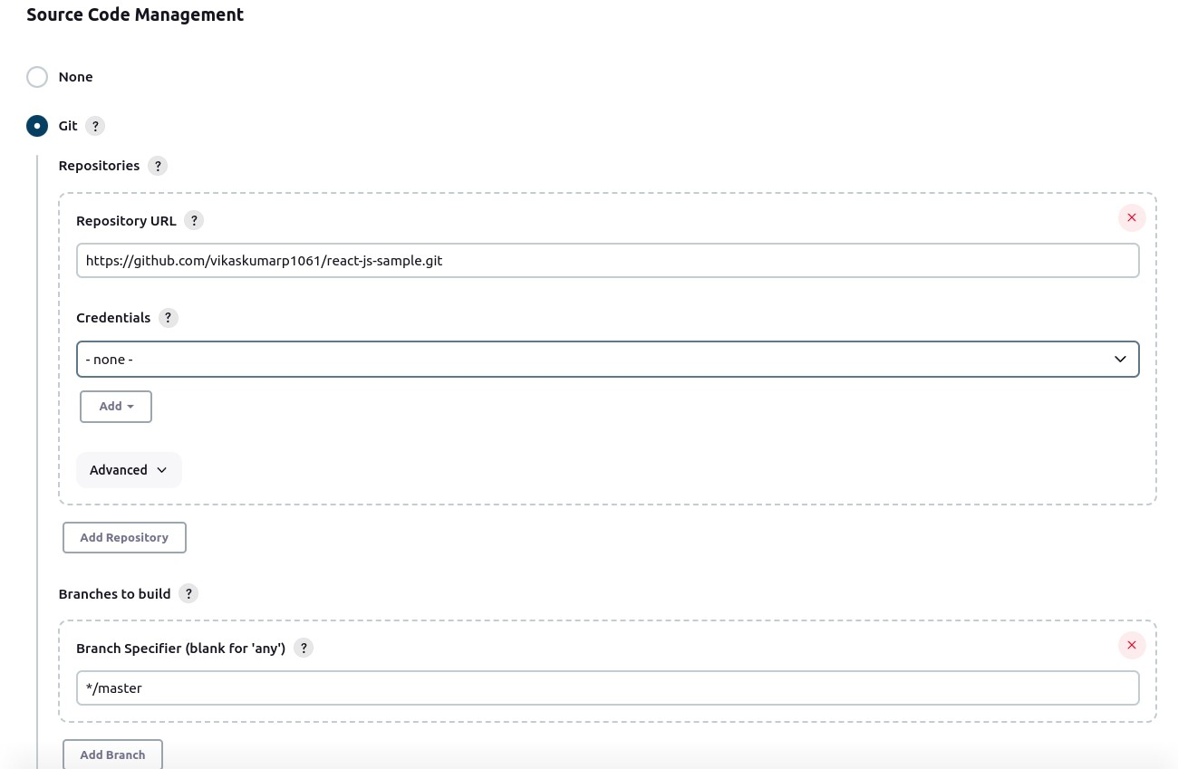

* Under “Build Environment”, select “Delete workspace before build starts” .
* Under “Build Steps” ,click on “execute shell script on remote host using ssh” and all the following commands.
* Do the same by adding one more build step called “Execute shell”.

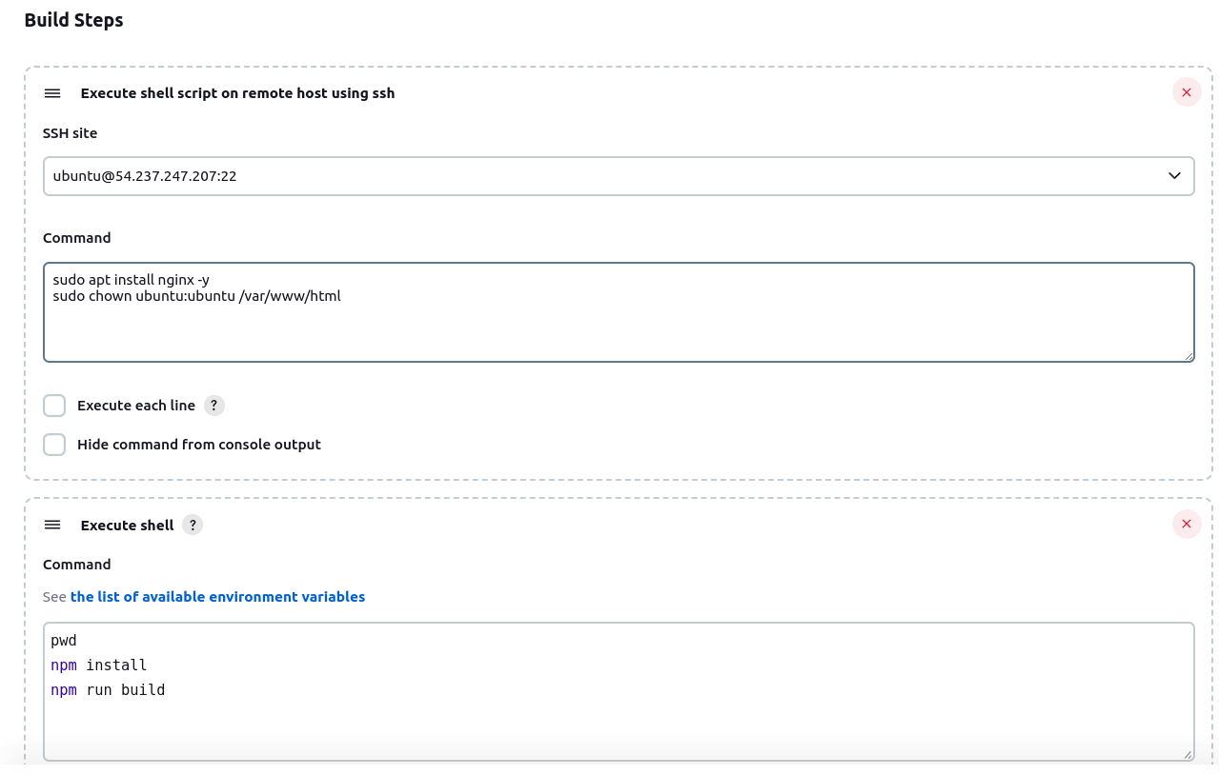

**STEP 4 :**

* Select “Post Build Actions” and use “Send build artifacts over SSH”
* Select the instance name and under source files,select the build folder
* Remove prefix is used to just copy the contents of build folder instead of the folder itself,so the folder will not be copied,but only files and directories inside it will be copied.
* Under Exec command,make sure to reload nginx to save the changes done.

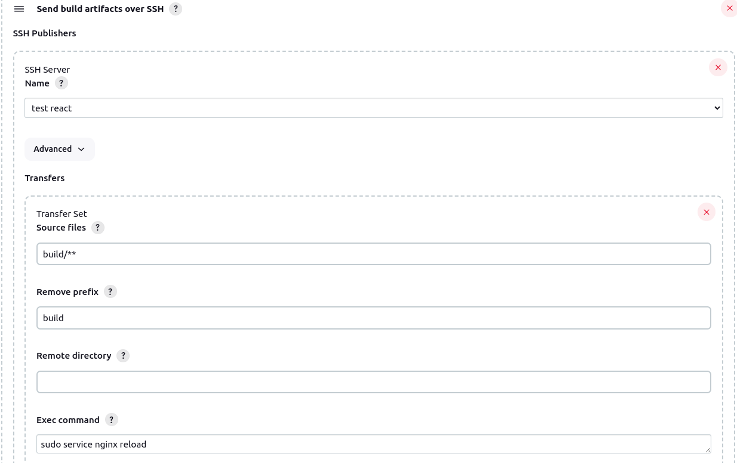

* Save and build the project, go into console output and wait for the project to be built.

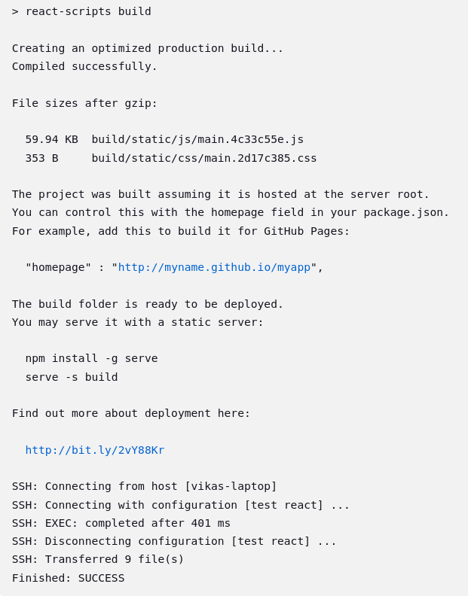

* Copy paste the ip address of the instance and paste it in browser,we will get the application which is automated and deployed on EC2 server.

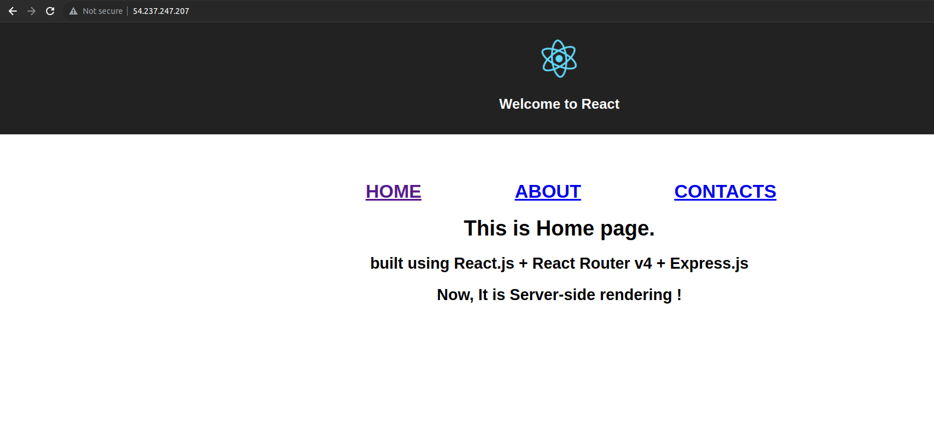

**STEP 5 :**

Configure Email notification upon the build success or failure.

* Move into Manage Jenkins > System
* Under “Extended Email Notification”, add the details as shown.
* Create a Credential and add the username as your email and password should be the app password.
  + To generate the app password ,first turn on 2 step authentication.
  + After that,click on Security > 2 step authentication > app passwords
  + Select the app as mail and the device which you are using and click on generate.

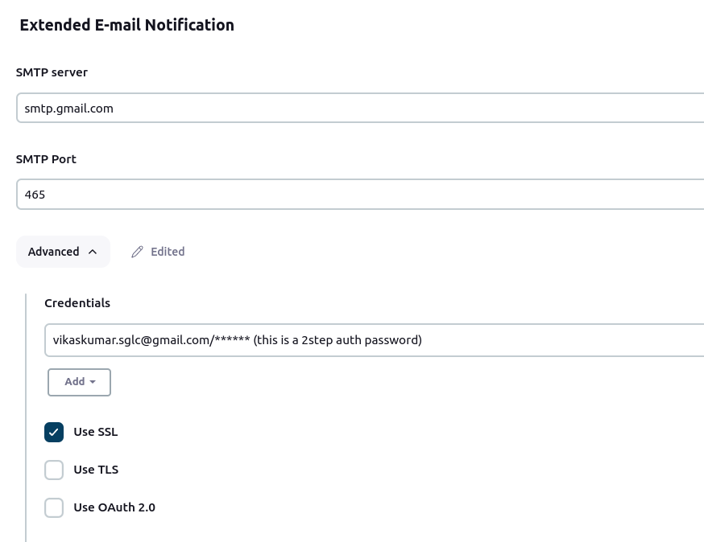

* Under “ E-mail Notification”,add the following details,under username,add the email id you generated password for , and add the password and SMTP port.

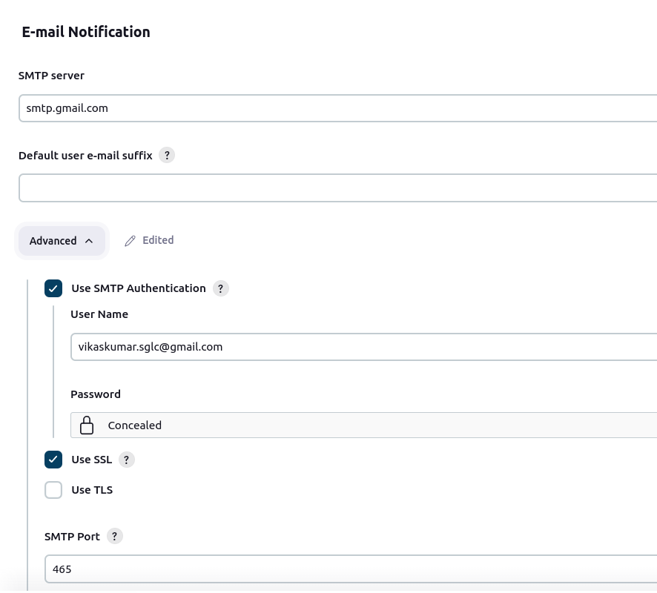

**STEP 6 :**

Update the project with email notification turned on.

* Select the project to which you want to add the email notification.
* Go to the post build action and select “**Editable Email Notification”.**
* Under “**Project Recipient List**” add the email address
* Click on advanced settings and scroll down to trigger options.
* Click on Add trigger and select “**Success”** option to send mail only when build is successful.
* Make sure to add “ **Recipient List** ” under “**Success”.**

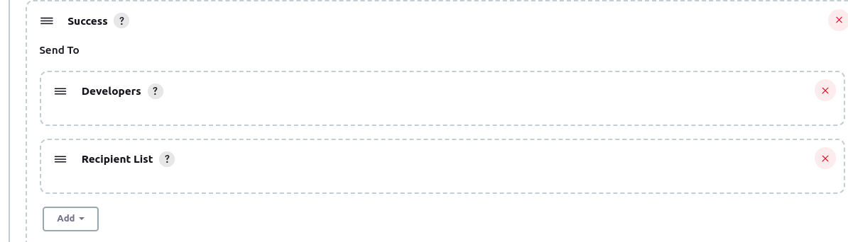

* Under “**Success”** ,click on advanced option and edit the options.
* Add email in “ **Recipient List** ”
* Change the **“subject”** , **“Content”** and **“Content type”** to your desired text.

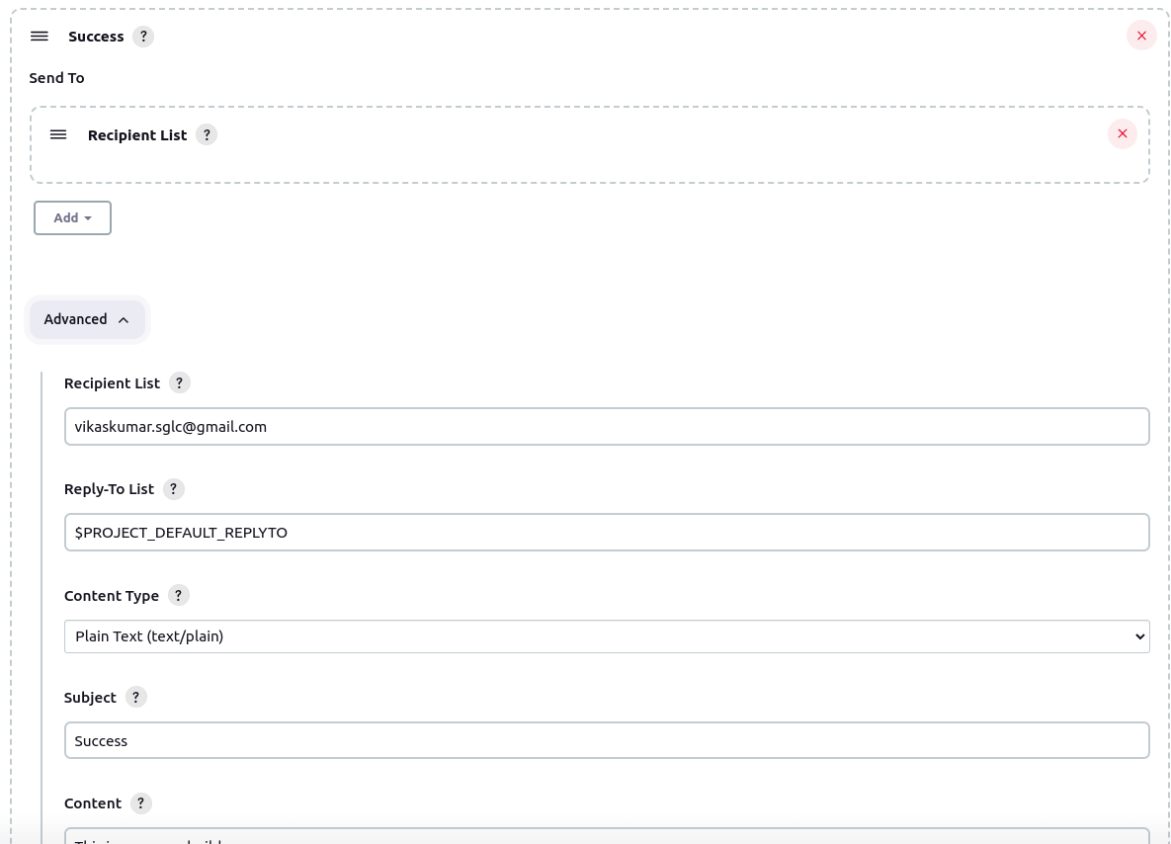

* Apply the changes and save the project, then build it
* The console output will show like this at the end if build is successful.

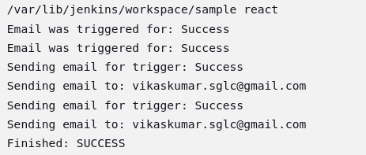

* Open the Email and check for the mail received.

